

COMSATS University Islamabad (SWL)
Project Proposal

For
Warehouse Inventory Alert System
By
Zrar Akbar (SP24-BCS-049)

INSTRUCTOR
Mam Mina Ali
(….Bachelor of Science in Computer Science ….)

SCOPE DOCUMENT REVISION HISTORY
No. | Comment | Action
1 |  | —
2 |  | —
3 |  | —
4
Supervisor Signature: ___________________ Date: ____________

1. Project Category
- Domain: Data Structures & Algorithms / Inventory Management
- Type: Console-Based / GUI Application
- Keywords: Inventory Management, Low Stock Alert, Linked List, Stack, GUI, Warehouse Automation

2. Abstract
Inventory management is a critical component of warehouse and supply chain operations. The Warehouse Inventory Alert System is a software application designed to efficiently manage warehouse products, track stock levels, and provide alerts for low-stock items.
The project is implemented in two phases:
- Mid-Term Version: Console-based system with core functionalities such as product addition, deletion, update, search, and low-stock alert.
- Final Version: GUI-based system with persistent storage, advanced analytics, reports, and user notifications.
The system uses linked lists for dynamic product storage and stacks for undo/redo operations, demonstrating practical applications of data structures in industry-relevant solutions.

3. Introduction
Warehouses face operational challenges in maintaining accurate records of product inventory. Inefficient inventory tracking can lead to:
- Stock-outs, resulting in production delays
- Overstocking, causing financial losses
- Difficulty in retrieving product information quickly
- Inefficient decision-making due to lack of reports
The Warehouse Inventory Alert System addresses these challenges by providing a digital, user-friendly platform to track and manage warehouse inventory dynamically.
The system is designed to:
- Maintain up-to-date product records
- Provide low-stock alerts
- Enable quick search and update operations
- Serve as a foundation for advanced warehouse management tools

4. Problem Statement
Manual or semi-automated warehouse systems are prone to human error and inefficiency. Key problems include:
- Difficulty in managing large inventories with multiple products
- Lack of real-time visibility into stock levels
- Inability to generate inventory reports quickly
- No automated alerts for low-stock items
This project aims to solve these problems by implementing a system that is dynamic, efficient, and scalable, using data structures to store, retrieve, and manage inventory data effectively.

5. Objectives
- Develop a Mid-Term console-based system to manage products in a warehouse
- Demonstrate DSA concepts such as linked lists and stacks
- Implement basic operations: Add, Delete, Update, Display, Search, Low-Stock Alert
- Develop a Final GUI version with advanced features including:
  - Persistent storage
  - Reporting & analytics
  - Undo/Redo functionality
  - Visual alerts for low-stock items
- Ensure the system is industry-relevant and user-friendly

6. Scope
Mid-Term Scope:
- Console-based interface
- Product management using linked lists
- Basic search and low-stock alert functionality
- Suitable for small to medium warehouse operations
Final Version Scope:
- GUI interface using Java Swing, C++ Qt, or Python Tkinter
- Persistent storage using files or database
- Advanced search, filtering, and sorting
- Analytics dashboard with reports
- Automated notifications for low-stock items
- Multi-user support for warehouse staff

7. Modules and Functionalities
Module | Description | DSA Used | Mid-Term / Final
Product Management | Add/Delete/Update products | Linked List | Mid-Term / Final
Display Module | Display all products | Linked List Traversal | Mid-Term / Final
Search Module | Search product by ID or Name | Linked List Traversal | Mid-Term / Final
Low Stock Alert | Show products below threshold | Linked List Traversal | Mid-Term / Final
GUI Interface | Forms, Tables, Buttons | N/A | Final
Persistent Storage | Save/load product data | File / Database | Final
Undo/Redo | Revert last actions | Stack | Final
Reports & Analytics | Inventory summaries | Array / Calculations | Final

8. Tools and Technologies

Tool / Component | Description
C++ / Java / Python | Backend programming and logic implementation
Linked Lists / Stack | Data structures for inventory management and undo/redo
MySQL / SQLite | Database for persistent storage (Final)
Java Swing / Qt / Tkinter | GUI development for final version
GitHub / Version Control | Code management and collaboration
Visual Studio Code / IDE | Development environment

9. Team Members & Work Division
Student Name | Registration Number | Responsibility
Zrar Akbar | SP24-BCS-049 | Full project development including backend logic, DSA implementation, console prototype, GUI development, database integration, reports, and documentation

10. Data Structure Design
Linked List for Product Management:
- Dynamic allocation of products
- Efficient addition and deletion of products
- Traversal for display, search, and low-stock alerts
Stack for Undo/Redo Operations (Final Version):
- Push operations for each change
- Pop to undo last action
- Supports multiple undo/redo operations
Array (optional):
- Temporary storage for sorted reports or analytics
- Supports advanced features in final version

11. System Design & Flow
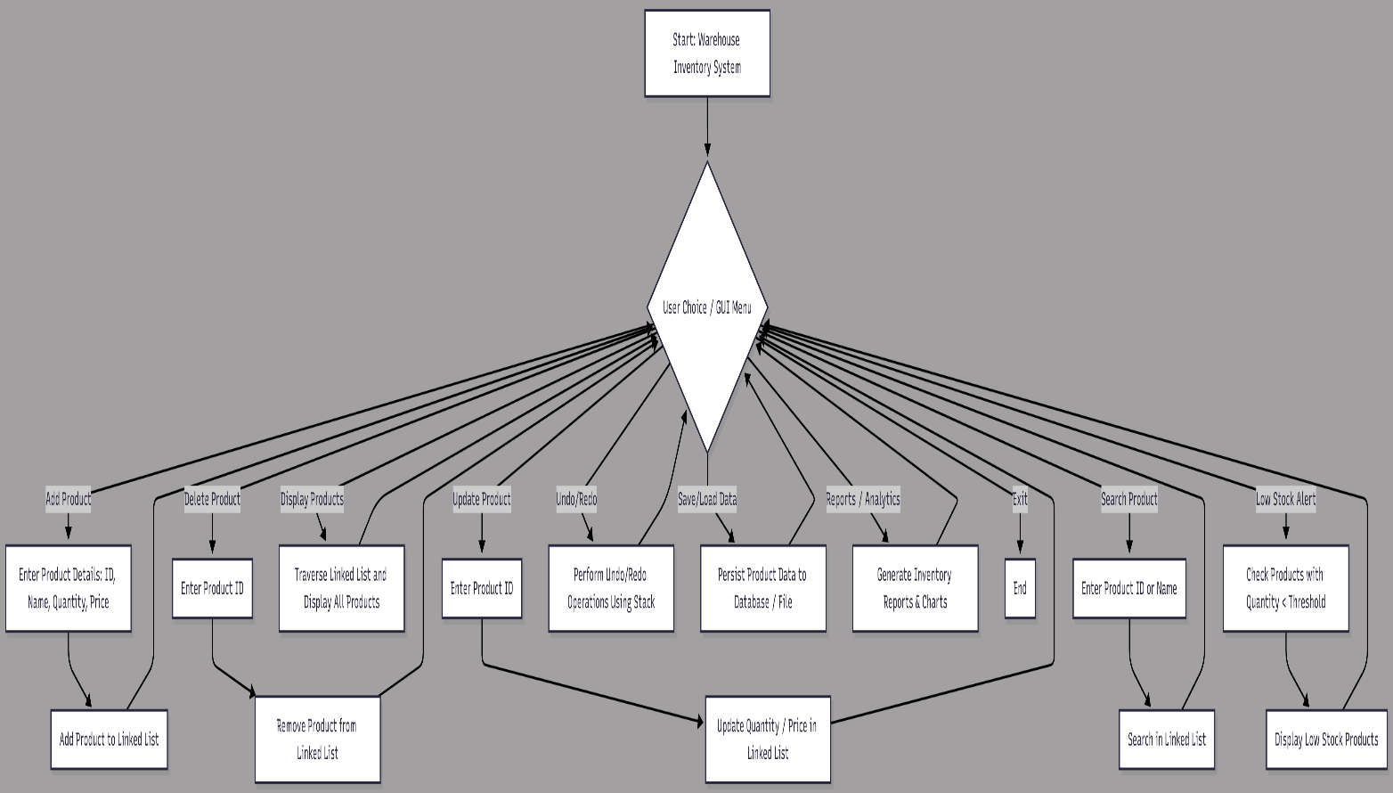

12. System Limitations
Mid-Term:
- No GUI (console-based)
- Data lost on program exit
- Single user
- Limited reporting
Final Version:
- Can be upgraded for multi-user, database, GUI
- Advanced notifications for low-stock

12. Future Enhancements
- Full GUI interface for better usability
- Database integration for persistent storage
- Automated notifications via email or system
- Advanced analytics and reports for inventory trends
- Multi-user support for warehouse operations
- Integration with barcode/RFID scanning for real-time updates

13. Industry Relevance
- Supports efficient warehouse operations
- Prevents stock-outs and overstocking
- Provides real-time visibility into inventory
- Can be used by small businesses or scaled for industrial warehouses
- Demonstrates practical application of DSA concepts in real-world scenarios

14. Conclusion
The Warehouse Inventory Alert System is designed to be a dynamic, scalable, and user-friendly inventory management solution.
- Mid-Term: Console-based system with core functionalities demonstrating DSA skills
- Final Version: GUI-based system with persistent storage, reports, alerts, and analytics for industry-level applications
This system not only serves as a practical project for academic evaluation but also has real-world industry relevance, showing how data structures can be applied to solve operational problems.

15. References
- Cormen, T. H., Leiserson, C. E., Rivest, R. L., & Stein, C. (2022). Introduction to Algorithms (4th ed.). MIT Press.
- Horowitz, E., Sahni, S., & Rajasekaran, S. (2011). Fundamentals of Data Structures in C++ (2nd ed.). Silicon Press.
- Rushton, A., Croucher, P., & Baker, P. (2017). The Handbook of Logistics and Distribution Management (6th ed.). Kogan Page.
- Heizer, J., Render, B., & Munson, C. (2020). Operations Management: Sustainability and Supply Chain Management (13th ed.). Pearson.
- Kim, S. W., & Lee, H. (2002). An inventory management system using information technology: Case studies in warehousing. International Journal of Production Economics, 78(1), 41–52. https://doi.org/10.1016/S0925-5273(02)00057-7
- GeeksforGeeks. (n.d.). Linked List in C++. Retrieved November 11, 2025, from https://www.geeksforgeeks.org/linked-list-set-1-introduction/
- GitHub Repository for Linked List Implementation in C++ (n.d.). Retrieved November 11, 2025, from https://github.com/topics/linked-list

